|  |  |
| --- | --- |
| linear IPS | Year 12 Specialist  TEST 3  Monday 1 July 2019  TIME: 45 minutes working  Classpads allowed  One page of notes  42 marks 6 Questions |

Name:_______________________________

Teacher: ____________________________

**Note: All part questions worth more than 2 marks require working to obtain full marks.**

Q1 ( 3 & 3 = 6 marks)

1. Solve for the following system of linear equations **without using a classpad**.



Q1 - continued

1. Determine the values of  such that such that the system has
2. Infinite solutions
3. No solutions

Q2 (2 & 3 = 5 marks)

If  , determine

1. 
2.  (no need to simplify)

Q3 (2, 3 & 3 = 8 marks)

An object is initially at the origin with initial speed of  and an acceleration given by

 at time  seconds.

Obtain an expression for the:

1. Velocity at time .
2. Position vector  at time .
3. Is the velocity ever perpendicular to the acceleration? Explain and if necessary solve for values (if any).

Q4 (3, 3, 3 & 3 = 12 marks)

Consider a cannon ball that is projected from the top of a building with speed  at an angle  to the surface of the roof. There is a constant cross wind of 3 metres per second acting against the ball and the acceleration due to gravity is  down as shown in the diagram below. (Note- let the origin be at the top of the building on the edge)

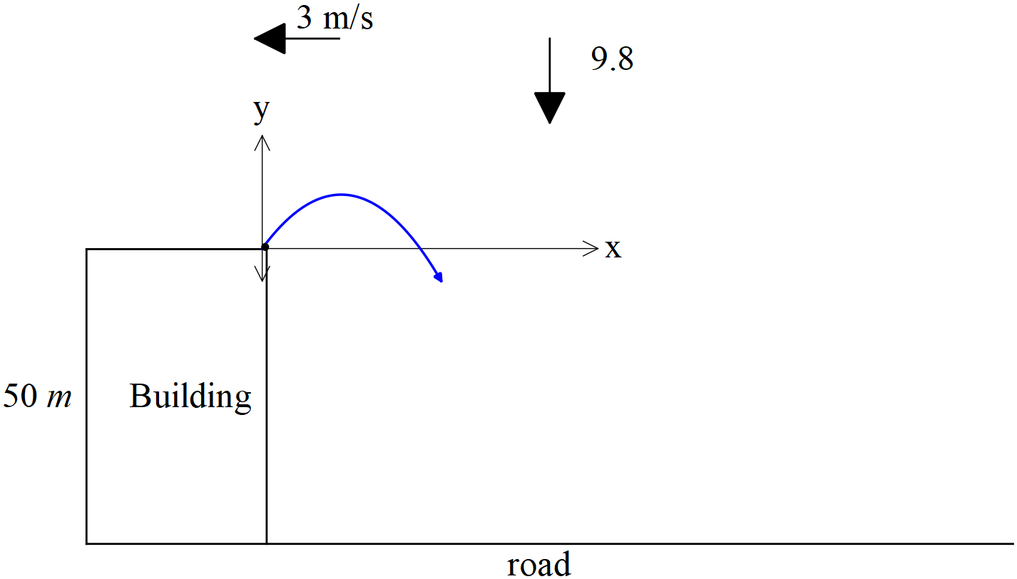

1. Given that the acceleration is given by  show using vector calculus that the velocity .
2. Determine the cartesian equation of the path of the cannon ball in terms of . Show your working.

Q4 continued

1. Given that a point on the cartesian path has been measured as  metres and the initial speed  of the ball from the cannon is 12 , determine the initial angle  of the ball when projected into the air.
2. If  and and a cross wind of  m/s as in the diagram on last page, determine how far from the foot of the building that the cannon ball lands on the road.

Q5 (2 & 5 = 7 marks)

Consider two rides at a circus, one is a merry go round and the other is a train on a straight line. Two twins decide to each try one of the two rides, Jane sits on the merry go round with a constant angular speed of  radians/minute moving in a clockwise direction and radius 6 metres and Mia sits on a train moving at 3 metres/minute away from the merry go round. See the diagram below.

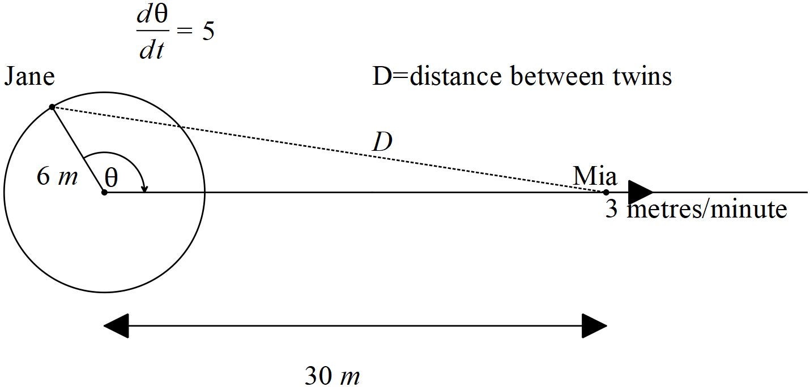

1. Determine the distance between Jane and Mia when  and the train is 30 metres from the centre of the merry go round.
2. Determine the time rate of change of this distance at the point defined in (a) above. (metres/minute)

Q6 (4 marks)

Given that  are functions of  , show that 